**RESUME**

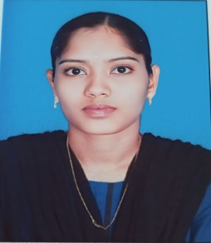**RAMYA P**

Mob:9345930919

Gmail:palaniramya9@gmail.com

______________________________________________________________

**CARRER OBJECTIVE :**

To secure a challenging position Where I can effectively contribute my skill

as software professional for growth of organizational and myself .

**EDUCATIONAL QUALIFICATION :**

|  |  |  |  |  |
| --- | --- | --- | --- | --- |
| **COURSE**  **NAME** | **INSTITUTION** | **BOARD/**  **UNIVERSITY** | **YEAR OF PASSING** | **AGGREGATE** |
| BCA  (Bachelor of computer Applications) | Navarasam arts and science college,Arachalur | Bharathiar University | Pursuing | Upto 4th sem  86% |
| HSC | Government Higher Secondary School | State Board | 2021 | 76.8% |
| SSLC | Government Higher Secondary School | State Board | 2019 | 59.4% |

**TEACHNICAL SKILL:**

* Programming Language **:** C , C++, JAVA , Python
* Web Teachnologies **:** HTML
* Application packages  **:** MS Office

**CO-CURRICULAR ACTIVITIES :**

* Attended the International conference on “Big Data And Analytics”.
* Participated in paper presentation on Data Science in Life Science.
* Certified in python course.

**EXTRA CURRICULAR ACTIVITIES :**

* Member of our college NSS.

**PERSONAL DETAILS :**

Address  **:** 13/381 A Sakthivinayagapuram ,Koduvai

Kangayam(TK),Tiruppur(DT)-638 660, Tamilnadu.

Father’s name **:** Mr.Palanisamy A

Mother’s name **:** Mrs.Velliayammal P

Date of Birth **:**  09/05/2004

Gender **:** Female

Language Known **:** Tamil, English, Telugu

Hobbies **:** Writing, gardening

**DECLARATION :**

Every detail above mentioned is true to the best of my knowledge And belief. I will be sincere and dedicated to my job.

**Place :**

**Date : (RAMYA P)**